14. Determination of the Shape Factor of a Paleostress Ellipsoid

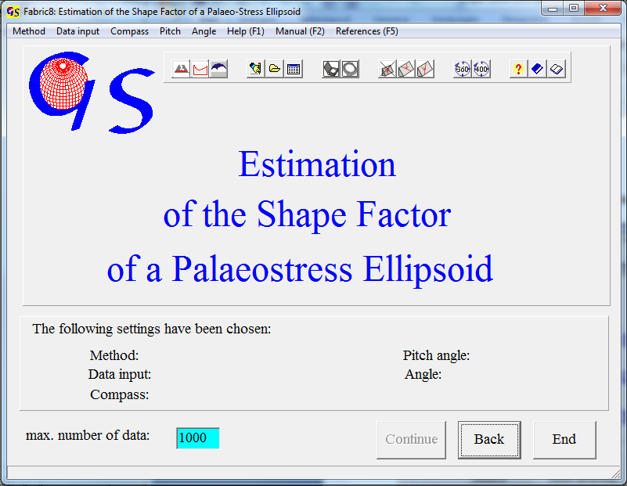
Fig. 1

The program 'Shape Factor' (Fig. 1) uses the Eigenvalue Method (WALLBRECHER et al., 1996) , the iteration method (ONKEN, 1988) and the direct inversion method to estimate the shape factor (R) of the regional stress ellipsoid.
The shape factor R is defined as:

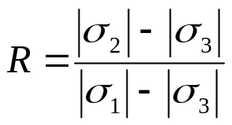
0 ≤ R ≤ 1

Before the R-values can be calculated, you have to determine the principal stresses σ₁ and σ₃ with the dihedra method. The program rotates all slickenside planes and striations into an orientation with σ₁ upright and σ₃ to the East. In this case the stress tensor is

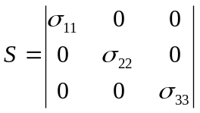.

In this coordinate system, the relation between the orientation of a plane and the factor R is defined with Bott‘s formula (Bott (1959) :

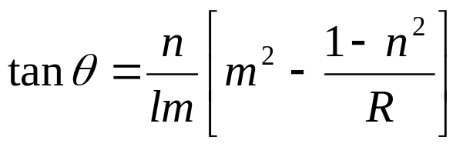
(Θ is the 'pitch' angle between the striation and the strike line oft he plane. L, m, and n are the direction cosines oft he normal tot he plane)

Eigenvalue Method:

With Bott's formula all theoretical striation directions on the measured slickenside planes are calculated for R = 0.0, 0.1, ...,1.0. Then the eigenvalues of these striations are calculated and plotted in a triangle. The eigenvalues of the measured striations are calculated as well and plotted in the triangle. By visual interpolation the R-value can now be estimated.

Iteration Method:

The fluctuation (F)

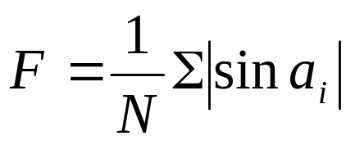

for various R-values is calculated.
The fluctuation is represented by arcussinus(F) and plotted against R (from R=0.0 to R=1.0). The minimum of this graph is interpreted as best estimation of R.

Direct Inversion Method

For each slickenside plane the R-value is calculated with Bott’s formula. A histogram is plotted with these values. Since the orientation of the striae depends only on the deviatoric part of the stress tensor, a dimensionless Mohr diagram is calculated for the stress tensor
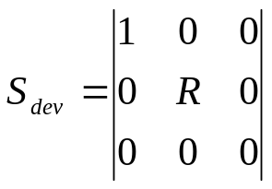.

For this stress tensor the normal and shear stresses (σ_{n}, σ_{s}) are calculated for each slickenside plane. They are found with the formulas
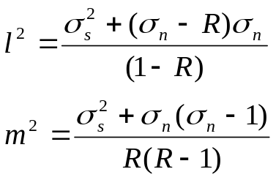
(l,m = direction cosine of the normal to a plane.)

σ_{n and} σ_{s} are then plotted into a dimensionless Mohr diagram. Mohr’s circles are found from the maximum of R in the histogram. You can optimize the fit of the circles by manual dragging of σ₂.

Data input is the same as in the programs 13, 14 und 15.

The graphic form for the eigenvalue method (Fig. 2) plots a data set which had already been cleaned with program 15. The principal stresses were estimated with program 13. They are σ₁ = 80/35 und σ₃ = 180/10. For the remaining slickenside planes the eigenvalues of the orientation matrices of theoretical striations were calculated for various R-values. In addition the eigenvalues of the orientation matrix of the measured striations were calculated. Since the sum of the normalized eigenvalues of each data set is always 1, they can be plotted in a triangle diagram. The theoretical eigenvalues are red; the measured ones are blue. Theoretical and measured eigenvalues are also listed in the table on the right side of the form.
A visual comparison of the measured values with those for the shape factors R = 0.0....1.0 results in a shape factor of
R ~ 0.9.
If the data set is consistent, all dots should lie on a line and the measured dot should be close to this line. (WALLBRECHER et al., 1996).

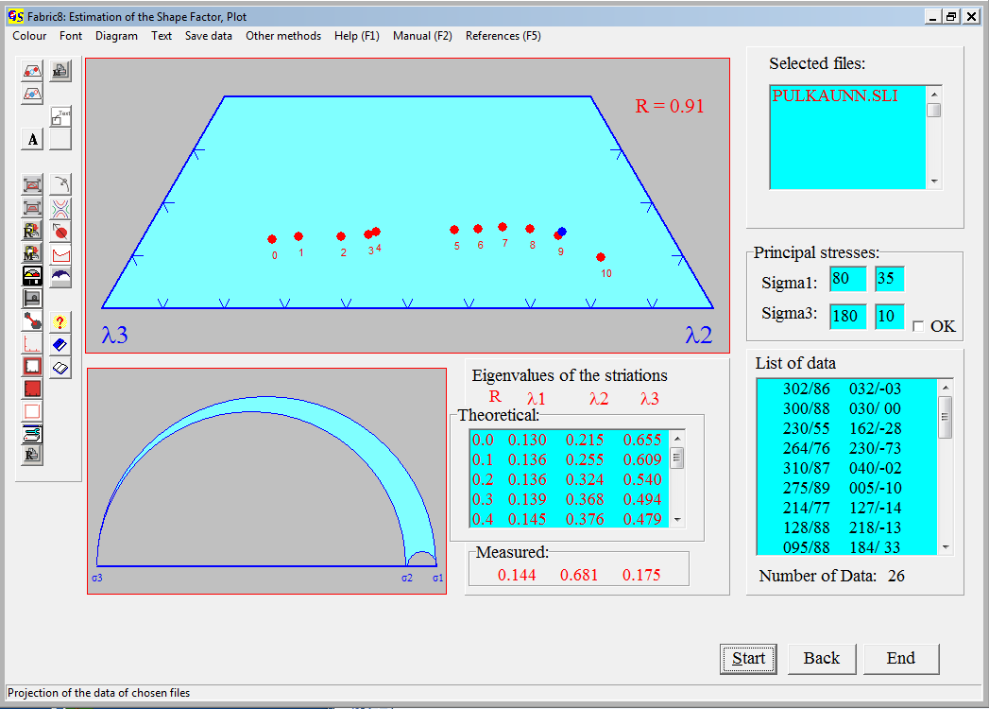
Fig. 2

Fig. 3 shows the graphic form for the iteration method.
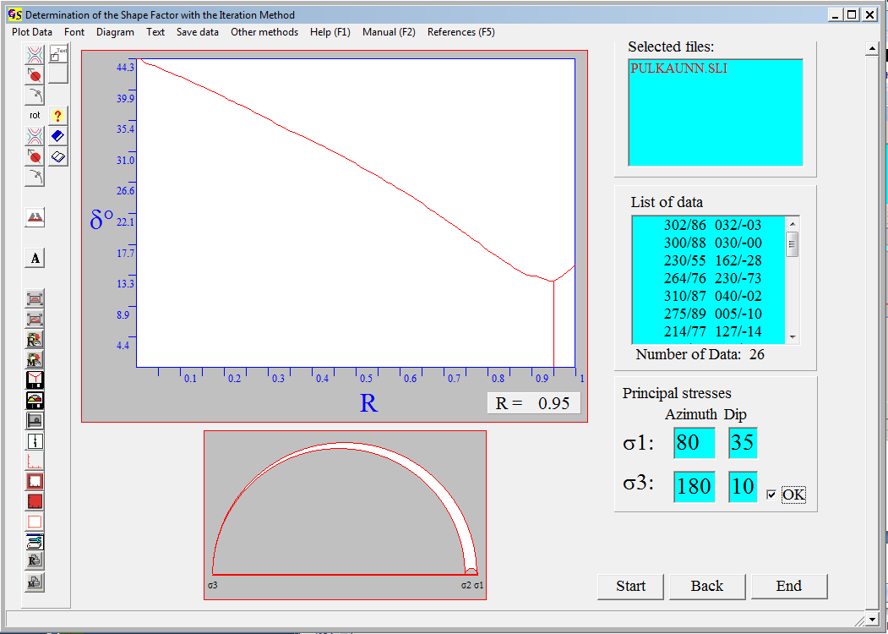
Fig. 3

The minimum of the fluctuation curve is at R = 0.95. This R-value is shown by the ratio of the three Mohr circles.
The menu “Plot data” (Fig. 4) shows the displacement data in a dihedra or

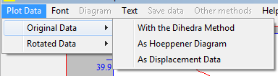
Fig. 4

Hoeppener diagram or as great circles and lineations in an equal area diagram.
This can be done for both, original and rotated data. This is to check the quality of the data. With the menu “Other methods” you can jump to any program which treats displacement data.

Fig. 4 shows the results for the direct method with the same data set.
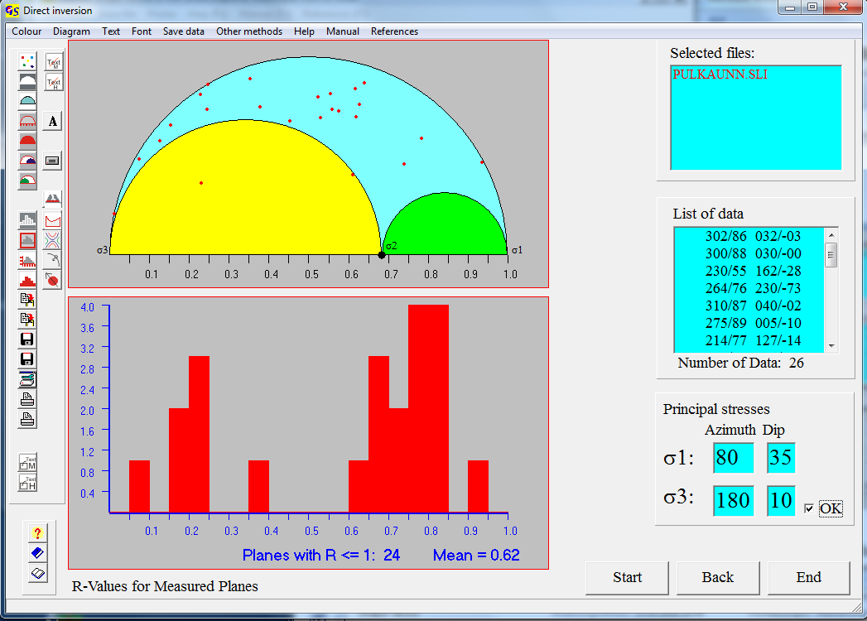
Fig. 4

The menu "Diagram" is described in Program 3. With the menu "Other methods" you can jump to the other programs which use displacement data.

